HINDI

MID – 1 SYLLABUS
SEMESTER – I
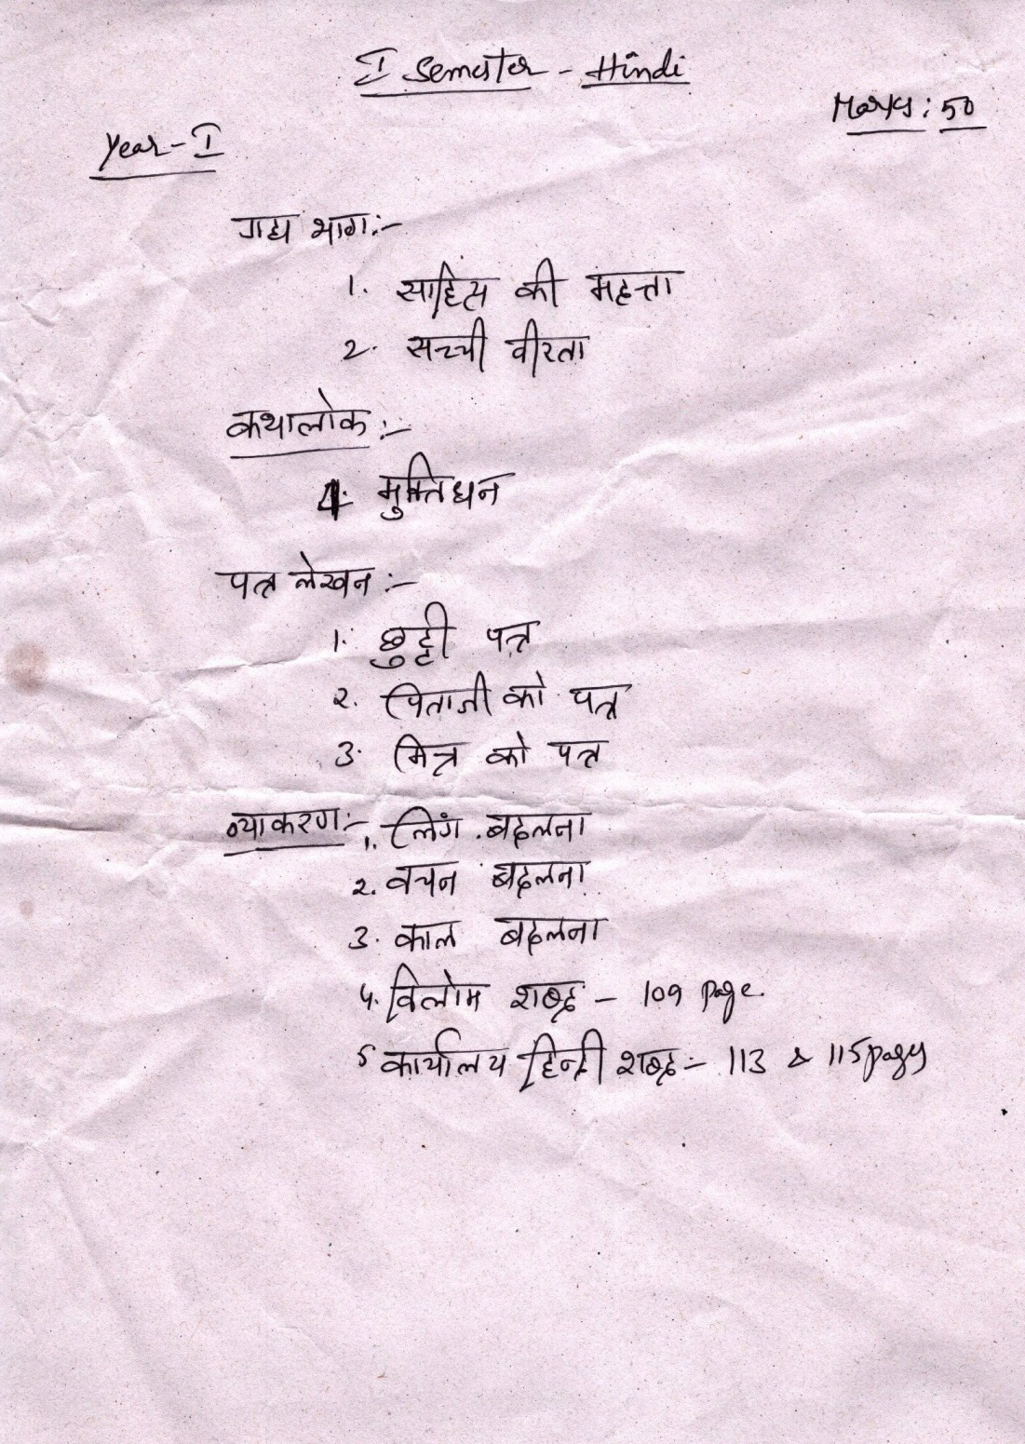

SEMESTER – III
