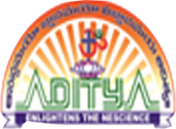
ADITYA DEGREE COLLEGES
ANDHRA PRADESH

MID – 1 SYLLABUS
HINDI
SEMESTER – I
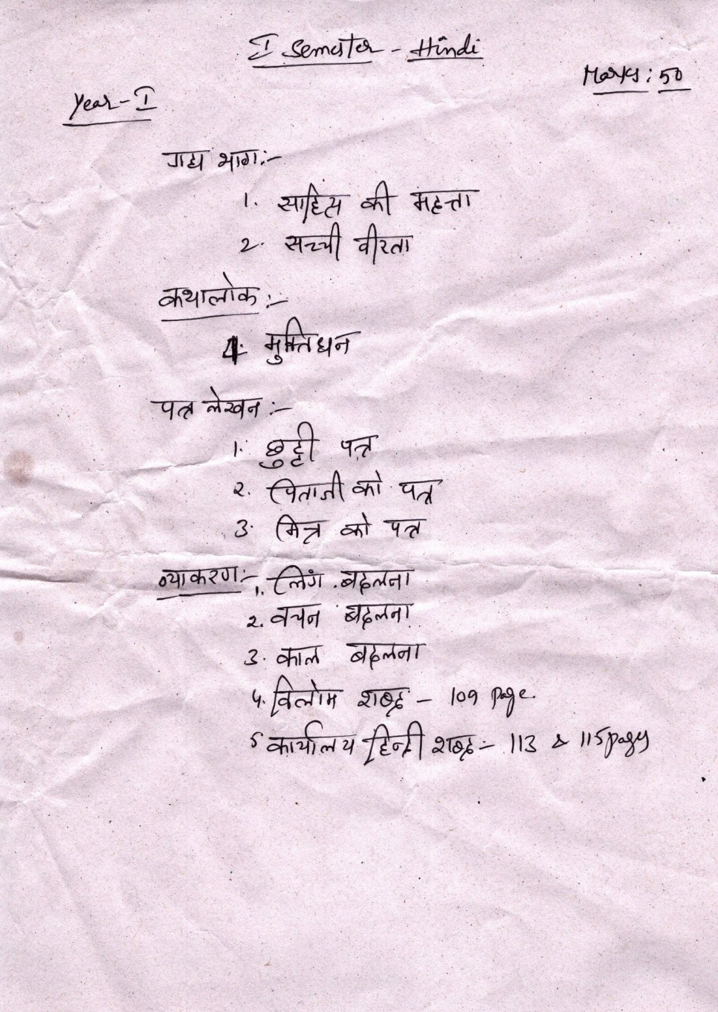

SEMESTER – III
