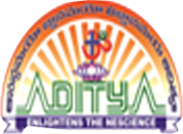
ADITYA DEGREE COLLEGES
ANDHRA PRADESH

MID – 1 SYLLABUS
HUMAN VALUES AND PROFESSIONAL ETHICS
SEMESTER – I

Unit-I : Introduction to Value Education

1. Value Education, Definition, Concept and Need for Value Education
2. The Content and Process of Value Education
3. Self-Exploration as a means of Value Education
4. Happiness and Prosperity as parts of Value Education

Unit-II: Harmony in the Human Being

1. Human Being is more than just the Body
2. Harmony of the Self (‘I’) with the Body
3. Understanding Myself as Co-existence of the Self and the Body
4. Understanding Needs of the Self and the Needs of the Body

